**Business Case: Target SQL**

Table of Contents

Objective 2

Inputs 2

Dataset 2

Relationship between datasets 2

Data Pre-processing 2

BigQuery workbench 2

Metadata of dataset 2

Describe the dataset by Table 3

Ordinal position 3

Data Exploration & Analysis 4

Customers Table 4

Sellers Table 5

Order Items Table 10

Payments Table 17

Orders Table 19

Reviews Table 23

Products Table 24

Insights 28

Recommendations 29

# 

# **Objective**

Analyze the given dataset from Target Store, derive insights and present the recommendations.

# **Inputs**

This business case has information of 100k orders from 2016 to 2018 made at Target in Brazil. Data is available in 8 csv files about customers, geolocation, order_items, payments, reviews, orders, products, and sellers.

## **Dataset**

<https://drive.google.com/drive/folders/1TGEc66YKbD443nslRi1bWgVd238gJCnb>

## **Relationship between datasets**

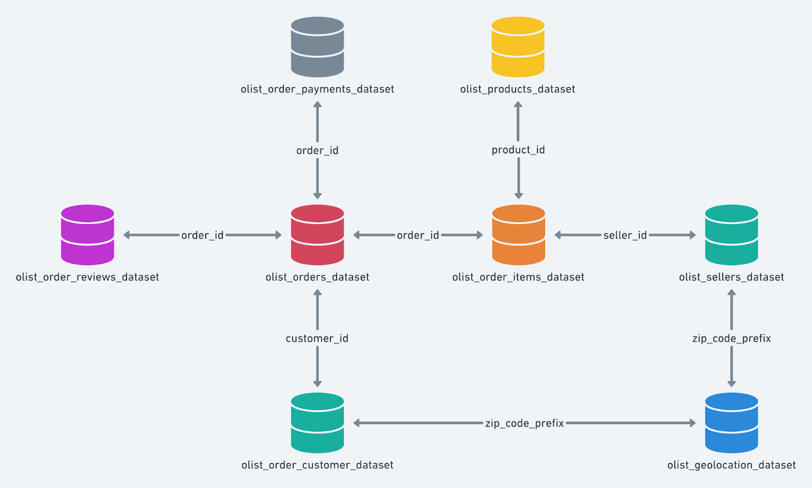

# **Data Pre-processing**

## **BigQuery workbench**

<https://console.cloud.google.com/bigquery?project=target-sql-361009>

## **Metadata of dataset**

SELECT * EXCEPT(is_generated, generation_expression, is_stored, is_updatable)

FROM `target-sql-361009.TargetDS.INFORMATION_SCHEMA.COLUMNS`

WHERE table_name = ‘customers’

SELECT * EXCEPT(is_generated, generation_expression, is_stored, is_updatable)

FROM `target-sql-361009.TargetDS.INFORMATION_SCHEMA.COLUMNS`

WHERE table_name = 'orders'

SELECT * EXCEPT(is_generated, generation_expression, is_stored, is_updatable)

FROM `target-sql-361009.TargetDS.INFORMATION_SCHEMA.COLUMNS`

WHERE table_name = 'payments'

SELECT * EXCEPT(is_generated, generation_expression, is_stored, is_updatable)

FROM `target-sql-361009.TargetDS.INFORMATION_SCHEMA.COLUMNS`

WHERE table_name = 'products'

## **Describe the dataset by Table**

DECLARE columns ARRAY<STRING>;

SET columns = (

WITH all_columns AS (

SELECT column_name

FROM `target-sql-361009.TargetDS.INFORMATION_SCHEMA.COLUMNS`

WHERE table_name = 'products'

and data_type IN ('INT64','FLOAT64'))

SELECT ARRAY_AGG((column_name) ) AS columns FROM all_columns );

## **Ordinal position**

SELECT * FROM `target-sql-361009.TargetDS.INFORMATION_SCHEMA.COLUMNS`

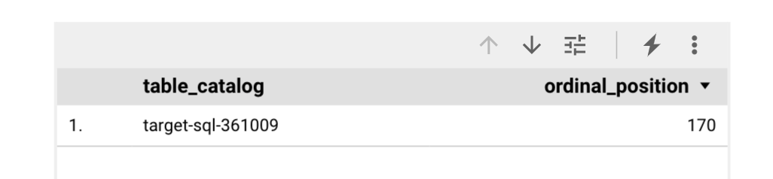

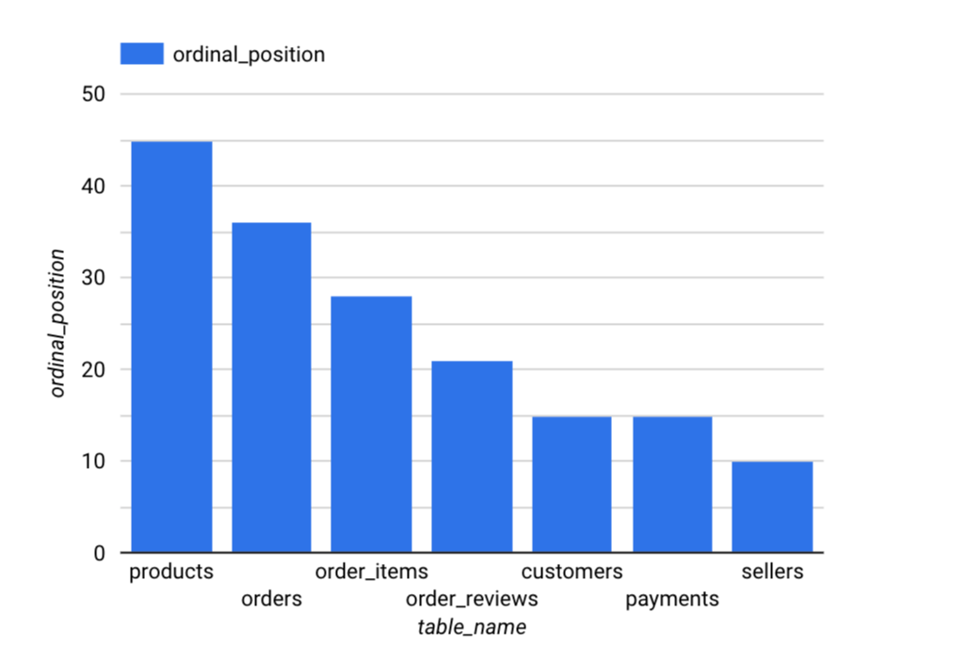

Data from geo_locations table may not be required as the same data available from other given tables.

# **Data Exploration & Analysis**

## **Customers Table**

1. Total Customers count

SELECT COUNT(customer_unique_id)

FROM `target-sql-361009.TargetDS.customers`

**99441**

1. Total Cities count

SELECT count(DISTINCT(customer_city))

FROM `target-sql-361009.TargetDS.customers`

**4119**

1. Total States count

SELECT count(DISTINCT(customer_state))

FROM `target-sql-361009.TargetDS.customers`

**27**

1. Top 10 States by Customers count

SELECT customer_state, COUNT(customer_id) AS cust_count

FROM `target-sql-361009.TargetDS.customers`

GROUP BY customer_state

ORDER BY cust_count DESC LIMIT 10

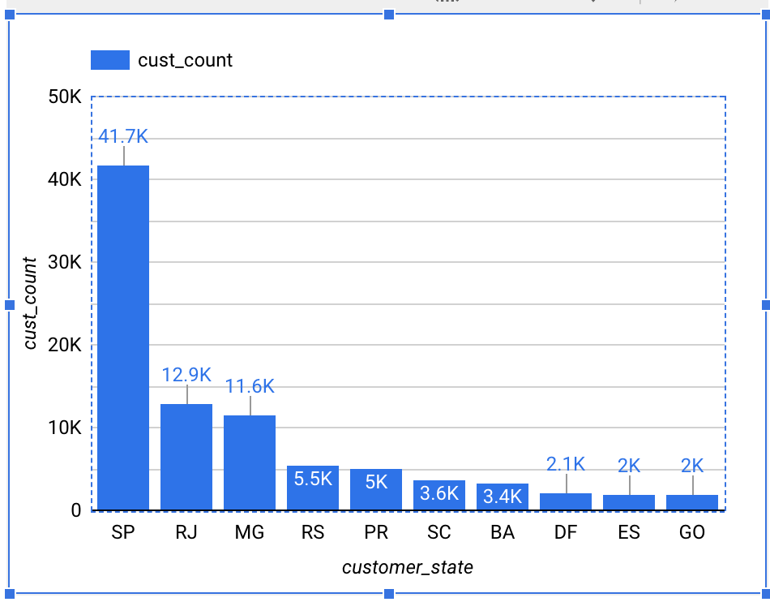

The states of San Paulo and Rio de janeiro have more Customers

1. Top 10 Cities in terms of Customer Count

SELECT customer_city, COUNT(customer_unique_id) cust_count

FROM `target-sql-361009.TargetDS.customers`

GROUP BY customer_city

ORDER BY cust_count DESC LIMIT 10

In line with the States, the respective cities indicate they have the high number of customers.

## **Sellers Table**

1. Total Sellers count

SELECT count(seller_id)

FROM `target-sql-361009.TargetDS.sellers`

**3095**

1. Total Cities count

SELECT COUNT(DISTINCT(seller_city))

FROM `target-sql-361009.TargetDS.sellers`

**611**

1. Total States count

SELECT COUNT(DISTINCT(seller_state))

FROM `target-sql-361009.TargetDS.sellers`

**23**

1. Top 10 Cities with high number of Sellers

SELECT seller_city, count(seller_id) AS seller_cnt

FROM `target-sql-361009.TargetDS.sellers`

GROUP BY seller_city

ORDER BY seller_cnt DESC LIMIT 10

1. Top 10 States with high number of Sellers

SELECT seller_state, count(seller_id) AS seller_cnt

FROM `target-sql-361009.TargetDS.sellers`

GROUP BY seller_state

ORDER BY seller_cnt DESC LIMIT 10

States of San Paulo, Curitiba and Rio continue to be on top even in terms of Sellers count.

1. Top 10 Cities of Sellers with high number of Orders

SELECT seller_city, count(order_item_id) order_cnt

FROM `target-sql-361009.TargetDS.sellers` sel

JOIN `target-sql-361009.TargetDS.order_items` order_item

ON sel.seller_id = order_item.seller_id

GROUP BY seller_city

ORDER BY order_cnt DESC LIMIT 10

1. Top 10 Cities of Sellers with high number of Orders

SELECT seller_city, count(distinct(sel.seller_id)) sel_cnt, count(order_item_id) order_cnt

FROM `target-sql-361009.TargetDS.sellers` sel

JOIN `target-sql-361009.TargetDS.order_items` order_item

ON sel.seller_id = order_item.seller_id

GROUP BY seller_city

ORDER BY order_cnt DESC LIMIT 10

Though Rio has more number of Sellers, but recorded less number of Orders as compared to other cities.

1. Top 10 Cities with low number of Sellers their respective count of Orders

SELECT seller_city, count(distinct(sel.seller_id)) sel_cnt, count(order_item_id) order_cnt

FROM `target-sql-361009.TargetDS.sellers` sel

ON sel.seller_id = order_item.seller_id

GROUP BY seller_city

ORDER BY order_cnt ASC LIMIT 10

The cities with low count of Sellers have also resulted in low number of Orders

1. Top 10 States of Sellers with high number of Orders

SELECT seller_state, count(distinct(sel.seller_id)) sel_cnt, count(order_item_id) order_cnt

FROM `target-sql-361009.TargetDS.sellers` sel

JOIN `target-sql-361009.TargetDS.order_items` order_item

ON sel.seller_id = order_item.seller_id

GROUP BY seller_state

ORDER BY order_cnt DESC LIMIT 10

High number of Sellers also have resulted in high number of Orders in the states.

1. States of less number of Sellers and their respective number of Orders

SELECT seller_state, count(distinct(sel.seller_id)) sel_cnt, count(order_item_id) order_cnt

FROM `target-sql-361009.TargetDS.sellers` sel

JOIN `target-sql-361009.TargetDS.order_items` order_item

ON sel.seller_id = order_item.seller_id

GROUP BY seller_state

ORDER BY order_cnt ASC LIMIT 10

The states with less number of Sellers have recorded low orders.

1. Top 10 States of Sellers with high number of Customers

SELECT seller_state, count(distinct(sel.seller_id)) sel_cnt, count(distinct(customer_id)) cust_cnt

FROM `target-sql-361009.TargetDS.sellers` sel

JOIN `target-sql-361009.TargetDS.order_items` order_item

ON sel.seller_id = order_item.seller_id

JOIN `target-sql-361009.TargetDS.orders` ord

ON order_item.order_id=ord.order_id

GROUP BY seller_state

ORDER BY cust_cnt DESC LIMIT 10

The states with high number of Sellers also seem to have high number of Customers.

1. States of less number of Sellers and their respective number of Orders

SELECT seller_state, count(distinct(sel.seller_id)) sel_cnt, count(distinct(customer_id)) cust_cnt

FROM `target-sql-361009.TargetDS.sellers` sel

JOIN `target-sql-361009.TargetDS.order_items` order_item

ON sel.seller_id = order_item.seller_id

JOIN `target-sql-361009.TargetDS.orders` ord

ON order_item.order_id=ord.order_id

GROUP BY seller_state

ORDER BY cust_cnt ASC LIMIT 10

The state of ‘AC’ seem to have only 1 Seller and 1 Customer.

## **Order Items Table**

1. Count of Orders, Order Items, Products and Sellers

SELECT count(DISTINCT(order_id)) AS OrderCnt, count(DISTINCT(order_item_id)) AS OrderItemCnt, count(DISTINCT(product_id)) AS ProductCnt, count(DISTINCT(seller_id)) AS SellerCnt

FROM `target-sql-361009.TargetDS.order_items`

1. Top 10 Products in terms of Price

SELECT product_id, price

FROM `target-sql-361009.TargetDS.order_items`

ORDER BY price DESC LIMIT 10

1. Top 10 Sellers

SELECT seller_id, count(distinct(order_id)) AS OrderId

FROM `target-sql-361009.TargetDS.order_items`

GROUP BY seller_id

ORDER BY OrderId DESC LIMIT 10

1. Products that are sold more

SELECT product_id, count(order_id) AS OrderId

FROM `target-sql-361009.TargetDS.order_items`

GROUP BY product_id

ORDER BY OrderId DESC LIMIT 10

1. Are there any Sellers who didn’t have any sales? - No

SELECT seller_id

FROM `target-sql-361009.TargetDS.order_items`

WHERE order_id is null

The above query returned zero results, which means all the registered sellers at Target are active and they have sales.

1. Seller who has maximum number of orders

SELECT seller_id, count(order_id) AS order_cnt

FROM `target-sql-361009.TargetDS.order_items`

GROUP BY seller_id

ORDER BY order_cnt DESC LIMIT 1

1. Seller with minimum number of orders

SELECT seller_id, count(order_id) AS order_cnt

FROM `target-sql-361009.TargetDS.order_items`

GROUP BY seller_id

ORDER BY order_cnt ASC LIMIT 1

1. Seller with maximum freight value

SELECT seller_id, freight_value

FROM `target-sql-361009.TargetDS.order_items`

GROUP BY seller_id, freight_value

ORDER BY freight_value DESC LIMIT 10

1. Correlation b/w product price and freight value

SELECT product_id, price, freight_value

FROM `target-sql-361009.TargetDS.order_items`

GROUP BY product_id, price, freight_value

ORDER BY freight_value DESC LIMIT 10

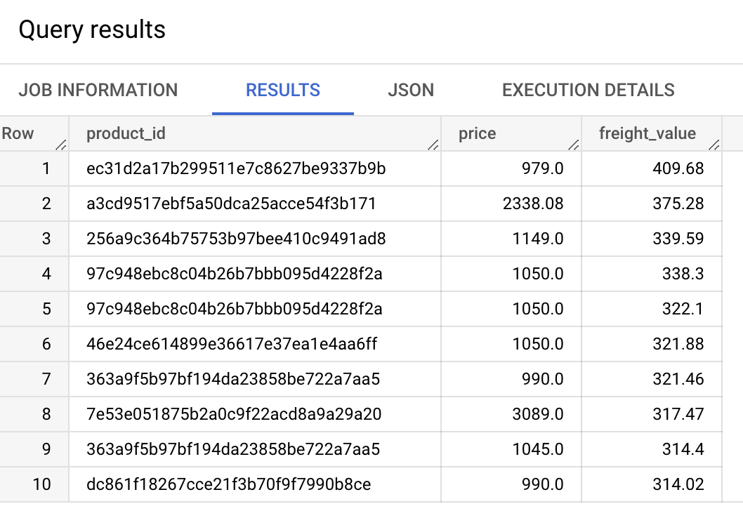

There is no correlation b/w the product price and high freight value

1. Seller who charges minimum freight value

SELECT seller_id, freight_value

FROM `target-sql-361009.TargetDS.order_items`

WHERE freight_value>0

GROUP BY seller_id, freight_value

ORDER BY freight_value ASC LIMIT 10

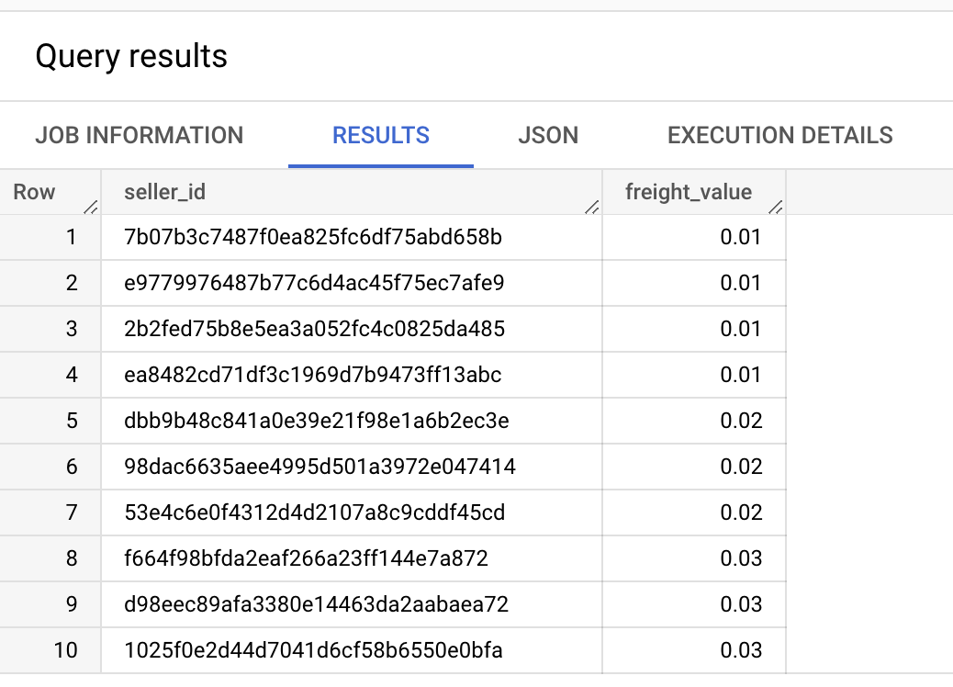

1. Sellers with zero freight value

SELECT seller_id, freight_value

FROM `target-sql-361009.TargetDS.order_items`

WHERE freight_value=0

GROUP BY seller_id, freight_value

ORDER BY freight_value

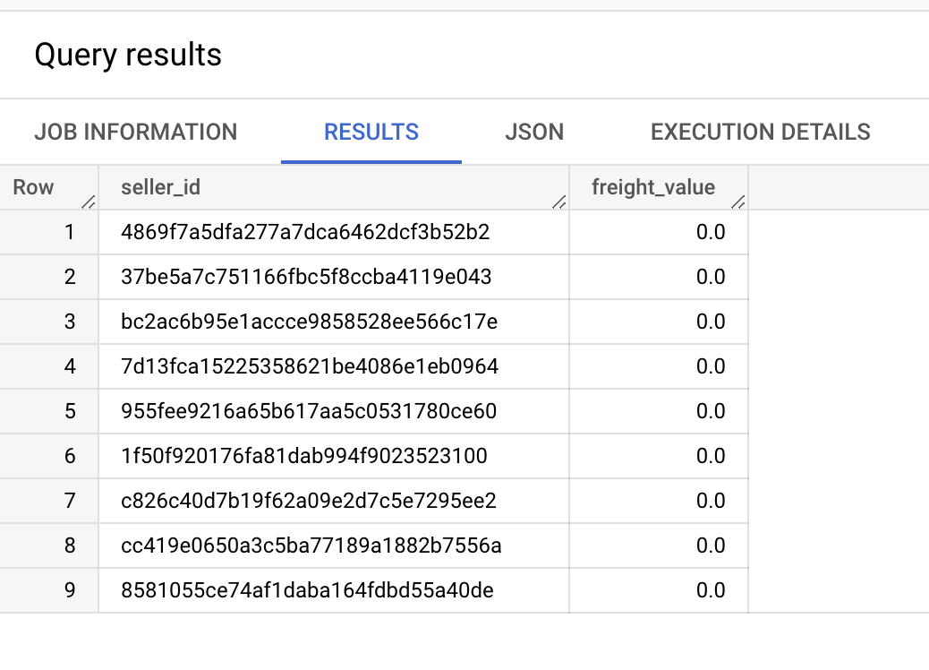

1. Sellers with zero freight value and their order count

SELECT seller_id, freight_value, count(order_id) AS order_cnt

FROM `target-sql-361009.TargetDS.order_items`

WHERE freight_value=0

GROUP BY seller_id, freight_value

ORDER BY order_cnt DESC

1. Sellers with zero freight value and their order count

SELECT count(distinct(seller_id)) AS seller_cnt, count(order_id) AS order_cnt

FROM `target-sql-361009.TargetDS.order_items`

WHERE freight_value=0

There are 9 sellers who have zero freight charges, their respective order counts.

1. Sellers with high freight value and their order count

SELECT seller_id, freight_value, count(order_id) AS order_cnt

FROM `target-sql-361009.TargetDS.order_items`

GROUP BY seller_id, freight_value

ORDER BY freight_value DESC LIMIT 10

The sellers with high freight value have less number of orders

1. Number of orders by Sellers whose freight value is above 20

SELECT count(distinct(seller_id)) AS seller_cnt, count(distinct(order_id)) AS order_cnt

FROM `target-sql-361009.TargetDS.order_items`

WHERE freight_value>20

30% of orders have freight value $20 and above.

1. Sellers with high number of orders and their freight value

SELECT seller_id, freight_value, count(order_id) AS order_cnt

FROM `target-sql-361009.TargetDS.order_items`

GROUP BY seller_id, freight_value

ORDER BY order_cnt DESC

This indicates that the sellers with relative lower freight value have higher number of orders

1. # of products whose freight value is between 10 and 20 and their order counts

SELECT count(distinct(product_id)) AS product_cnt, count(distinct(order_id)) AS order_cnt

FROM `target-sql-361009.TargetDS.order_items`

WHERE freight_value BETWEEN 10 AND 20

This indicates that 80% of orders are from products who have freight value b/w 10 and 20

1. # of products whose freight value is between 1 and 10 and their order counts

SELECT count(distinct(product_id)) AS product_cnt, count(distinct(order_id)) AS order_cnt

FROM `target-sql-361009.TargetDS.order_items`

WHERE freight_value>0 AND freight_value<=10

This indicates that 13% of orders are from products who have freight value less than 10.

## **Payments Table**

1. Total count of orders from Payments table

SELECT count(order_id) AS total_order, count(distinct(order_id)) AS distinct_order FROM `target-sql-361009.TargetDS.payments`

1. List of Payment Types, respective order counts and their total payment value

SELECT distinct(payment_type), count(order_id) AS order_cnt,

round(sum(payment_value),2) AS total_payment_value

FROM `target-sql-361009.TargetDS.payments`

GROUP BY payment_type

ORDER BY order_cnt DESC

Clearly credit card seems to be the most preferred payment type, followed by UPI.

1. Total Payment value by all orders

SELECT round(sum(payment_value), 2) AS total_payment_value

FROM `target-sql-361009.TargetDS.payments`

1. Top 10 orders with high payment value

SELECT order_id, payment_value

FROM `target-sql-361009.TargetDS.payments`

ORDER BY payment_value DESC LIMIT 10

1. Maximum possible payment instalment

SELECT max(payment_installments) as max_pmt_installment FROM `target-sql-361009.TargetDS.payments`

This indicates maximum possible instalment duration is Two years.

1. Top 10 orders by payment instalment and their respective count (Number of instalments pattern)

SELECT payment_installments AS inst_duration, count(payment_installments) AS inst_cnt FROM `target-sql-361009.TargetDS.payments`

GROUP BY payment_installments

ORDER BY inst_cnt DESC

1. Top 10 orders by payment instalment and their respective count (Number of instalments pattern)

SELECT payment_installments AS inst_duration, count(payment_installments) AS inst_cnt FROM `target-sql-361009.TargetDS.payments`

GROUP BY payment_installments

ORDER BY inst_duration DESC

Based on above two data points, interestingly Customers seem to prefer/paid lower instalment than dragging it too long.

## **Orders Table**

1. Number of orders from Orders table

SELECT count(order_id) AS order_cnt, count(distinct(order_id)) AS ord_distinct_cnt FROM `target-sql-361009.TargetDS.orders`

1. Number of orders and customers

SELECT count(order_id) AS order_cnt, count(distinct(customer_id)) AS cust_cnt

FROM `target-sql-361009.TargetDS.orders`

1. List of Order status and corresponding number of Orders

SELECT distinct(order_status), count(order_id) AS order_cnt

FROM `target-sql-361009.TargetDS.orders`

GROUP BY order_status

ORDER BY order_cnt DESC

This indicates 97% of the orders are delivered & completed.

1. Delay b/w order_delivery dates by customer & carrier

SELECT date_diff(order_delivered_customer_date, order_delivered_carrier_date, DAY) as delivery_delay,

FROM `target-sql-361009.TargetDS.orders`

ORDER BY delivery_delay DESC LIMIT 10

1. Delay b/w order_delivery dates by customer & carrier

SELECT date_diff(CAST(order_delivered_customer_date AS DATE), CAST(order_delivered_carrier_date AS DATE), WEEK) as delivery_delay_inWeeks,

FROM `target-sql-361009.TargetDS.orders`

ORDER BY delivery_delay_inWeeks DESC LIMIT 10

1. Time duration from Order to Delivery dates

SELECT date_diff(CAST(order_delivered_customer_date AS DATE), CAST(order_purchase_timestamp AS DATE), WEEK) as order_to_delivery,

FROM `target-sql-361009.TargetDS.orders`

ORDER BY order_to_delivery DESC LIMIT 10

Based on the above queries, it’s heartening to see the ‘Order to delivery’ is 30 weeks and there around % of orders with more than 20 weeks delivery duration, which is not good.

1. Month-wise Order count

SELECT FORMAT_DATETIME("%B", DATETIME(order_purchase_timestamp)) as order_month, count(order_id) order_cnt

FROM `target-sql-361009.TargetDS.orders`

GROUP BY order_month

ORDER BY order_cnt DESC

August is the top order month. August, May and July have more number of Orders. September is the lowest number of Orders.

1. Day-wise Order count

SELECT FORMAT_DATETIME("%a", DATETIME(order_purchase_timestamp)) as order_day, count(order_id) order_cnt

FROM `target-sql-361009.TargetDS.orders`

GROUP BY order_day

Surprisingly the number of orders relatively seem to be less on week-ends compared to week-days, and Monday being the top order day.

1. Day of month with high number of Orders

SELECT FORMAT_DATETIME("%d", DATETIME(order_purchase_timestamp)) as day_of_month, count(order_id) order_cnt

FROM `target-sql-361009.TargetDS.orders`

GROUP BY day_of_month

ORDER BY order_cnt DESC

There doesn’t seem to be any pattern in terms of which date of a month more orders are placed, like salary week or mid week or anything like that.

1. The days which recorded highest number of orders

SELECT FORMAT_DATETIME("%c", DATETIME(order_purchase_timestamp)) as day_of_month, count(order_id) order_cnt

FROM `target-sql-361009.TargetDS.orders`

GROUP BY day_of_month

ORDER BY order_cnt DESC

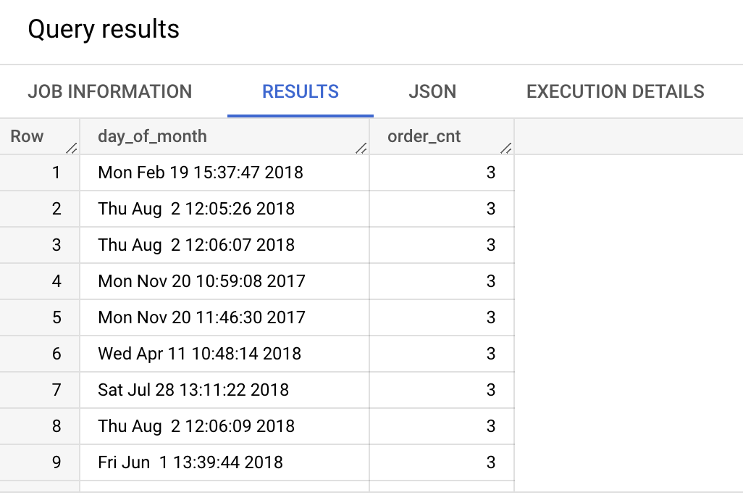The day of the year with highest number of orders in a single day seems to be Aug 2nd.

1. Year-wise count of Orders

SELECT EXTRACT(YEAR FROM DATE (order_purchase_timestamp)) as order_year, count(order_id) order_cnt

FROM `target-sql-361009.TargetDS.orders`

GROUP BY order_year

ORDER BY order_cnt DESC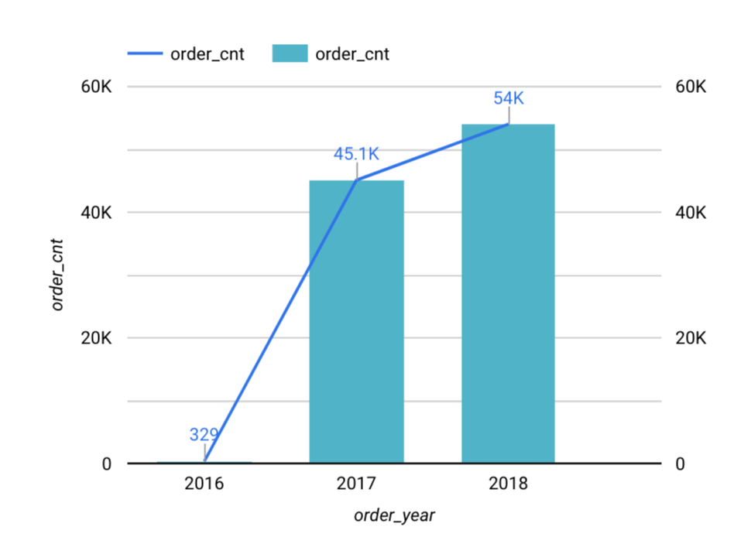

This is clear indication of how sales/e-commerce has increased over the years in Brazil.

## **Reviews Table**

1. Orders with top review scores

SELECT review_score, count(order_id) as order_cnt FROM `target-sql-361009.TargetDS.order_reviews`

1. The days which recorded highest number of orders

SELECT FORMAT_DATETIME("%c", DATETIME(order_purchase_timestamp)) as day_of_month, count(order_id) order_cnt

FROM `target-sql-361009.TargetDS.orders`

GROUP BY day_of_month

ORDER BY order_cnt DESC

The day of the year with highest number of orders in a single day seems to be Aug 2nd.

1. Year-wise count of Orders

SELECT EXTRACT(YEAR FROM DATE (order_purchase_timestamp)) as order_year, count(order_id) order_cnt

FROM `target-sql-361009.TargetDS.orders`

GROUP BY order_year

This is clear indication of how sales/e-commerce has increased over the years in Brazil.

## **Reviews Table**

1. Orders with top review scores

SELECT review_score, count(order_id) as order_cnt FROM `target-sql-361009.TargetDS.order_reviews`

GROUP BY review_score

ORDER BY order_cnt DESC

57% of the total orders have got top review score and 11% has got low review score.

## **Products Table**

1. Total number of Products

SELECT count(product_id) prod_cnt

FROM `target-sql-361009.TargetDS.products`

1. Top 10 Product Categories in terms of count

SELECT product_category, count(product_id) prod_cnt

FROM `target-sql-361009.TargetDS.products`

GROUP BY product_category

ORDER BY prod_cnt DESC LIMIT 10

The top 3 product categories with more number of products are ‘bed table bath’, ‘sports’, and ‘furniture’

1. The product categories with more number of orders

SELECT product_category, count(order_item_id) order_cnt

FROM `target-sql-361009.TargetDS.products` prod

LEFT JOIN `target-sql-361009.TargetDS.order_items` order_item

ON prod.product_id = order_item.product_id

GROUP BY product_category

ORDER BY order_cnt DESC LIMIT 10

The top 3 product categories with more number of orders are ‘bed table bath’, ‘health beauty’ and ‘sports’.

1. The product categories with less number of orders

SELECT product_category, count(order_item_id) order_cnt

FROM `target-sql-361009.TargetDS.products` prod

LEFT JOIN `target-sql-361009.TargetDS.order_items` order_item

ON prod.product_id = order_item.product_id

GROUP BY product_category

ORDER BY order_cnt ASC LIMIT 10

Insurance and Services and Children’s Fashion Clothing are the product categories with less number of orders.

1. Top 10 Product Categories with high number of Photos

SELECT product_category, count(product_id) prod_cnt, product_photos_qty

FROM `target-sql-361009.TargetDS.products`

GROUP BY product_category, product_photos_qty

ORDER BY product_photos_qty DESC LIMIT 10

Though ‘Toys’ has only one product, the number of product images are high. Similarly we can see babies and pet products have more photos.

1. Product categories that don’t have photo images

SELECT product_category, count(product_id) prod_cnt, product_photos_qty

FROM `target-sql-361009.TargetDS.products`

WHERE product_photos_qty=0

GROUP BY product_category, product_photos_qty

LIMIT 10

This query has returned with zero which indicates all the products have atleast one product image.

1. Top 10 Product Categories with atleast one photo image

SELECT product_category, count(product_id) prod_cnt, product_photos_qty

FROM `target-sql-361009.TargetDS.products`

WHERE product_photos_qty=1

GROUP BY product_category, product_photos_qty

ORDER BY prod_cnt DESC

LIMIT 10

1. Correlation b/w product order count and list of images they have

SELECT product_category, count(order_item_id) order_cnt, product_photos_qty

FROM `target-sql-361009.TargetDS.products` prod

JOIN `target-sql-361009.TargetDS.order_items` order_item

ON prod.product_id = order_item.product_id

GROUP BY product_category, product_photos_qty

ORDER BY order_cnt DESC LIMIT 10

Having a photo image of the product doesn’t influence on number of orders

1. Orders trend by month

SELECT FORMAT_DATETIME("%B", DATETIME(order_purchase_timestamp)) as order_month, count(order_id) order_cnt, customer_state

FROM `target-sql-361009.TargetDS.orders` ord

INNER JOIN `target-sql-361009.TargetDS.customers` cust

ON ord.customer_id = cust.customer_id

GROUP BY order_month, customer_state

ORDER BY order_cnt DESC LIMIT 12

# **Insights**

The following insights can be derived from the given dataset.

Cities, States, Customers & Sellers:

* Top states with more Customers - San Paulo, Rio de janeiro
* Top states with more Sellers - San Paulo, Curitiba and Rio continue
* All the registered sellers at Target are active and they have sales
* Cities and States with more number of Sellers have recorded high number of Orders
* There is no correlation b/w the product price and high freight value

Orders:

* August is the top order month.
* August, May and July have more number of Orders.
* September has the lowest number of Orders
* Surprisingly the number of orders relatively seem to be less on week-ends compared to week-days, and Monday being the top order day.
* There doesn’t seem to be any pattern in terms of which date of a month more orders are placed, like salary week or mid week or anything like that.

Freight Value:

* High freight value have less number of orders
* Lower freight value have higher number of orders
* There are 9 orders with zero freight charges, and their total order count is 383
* 30% of orders have freight value $20 and above
* 80% of orders are from products who have freight value between 10 and 20
* 13% of orders are from products who have freight value less than 10

Payment Options:

* Preferred payment option is Credit Card with 78%
* UPI mode of payment is 17%
* Voucher holds 2% of overall payment value

Instalments:

* Maximum instalment duration is Two years
* Customers seem to prefer/paid lower instalment than dragging it too long. 80% of the instalments are within first 4 months

Delivery:

* Delivery status indicates 97% of the orders are delivered & completed
* Only 0.6% of total orders either cancelled or unavailable which is a good sign
* It’s heartening to see the ‘Order to delivery’ is 30 weeks and there around good number of orders with more than 20 weeks delivery duration, which is not good.

Reviews:

* 57% of the total orders have got top review score
* 11% of the orders have got low review score

Products:

* The top 3 product categories with more number of orders are ‘bed table bath’, ‘health beauty’ and ‘sports’.
* ‘Insurance and Services’ and ‘Children’s Fashion Clothing’ are the product categories with less number of orders.
* Though ‘Toys’ has only one product, the number of product images are high. Similarly we can see babies and pet products have more photos.
* All the products have atleast one product image.

# **Recommendations**

Based on the given dataset and above analysis, some of the recommendations are:

* States like Acre (AC), Amazonas (AM), Bahia (BA) are with less number of Customers. Incidentally Sellers count also low in those states, and there by Sales are low in these states. Target can increase the number of Sellers to attract more customers and more orders
* In such above States & Cities, Target can come up with seasonal promotions and increase Customer count
* The location/region where UPI payment is not used, probably because UPI payment type is not available OR people are not still comfortable to use that option in that location/region. Target can check and provide the option appropriately.
* The location where voucher payment type is not/less used, probably Target can give voucher promotions in that region.
* If a particular state/city is not/less using the instalment type means, probably the given duration of 2 years may not be suffice. Target can try to increase the instalment duration in those regions and see if it attracts more customers.
* Customers who make frequent purchases – recognize them with rewards, privileges
* Come up with promotions for the months like September where Sales is low
* Freight charges are really high for few orders which certainly need to be looked at reduced
* Order to delivery duration is seemingly high for few orders which certainly have to be sorted out
* ‘Insurance and Services’, ‘Children’s Fashion Clothing’, ‘PC Gamer’ are the product categories with less sales, which is an area of opportunity to improve
* There are 11% or Orders with low review scores. Target must review these scores and improve based on the given user comments.